GSTEORE002 - GeoAI-Based Water Body Extraction frv om Sentinel-2 Satellite Images Using U-Net Semantic Segmentation
First Author¹[0000-1111-2222-3333] and Second Author²[1111-2222-3333-4444]
K R Manjula1^{1[00000000]}, L Gowri², S Anand Kumar Varma³
^{1&2}School of Computing, SASTRA Deemed University, Thanjavur, India
³Gnanamani College of Technology, Namakkal, India
*manjula@cse.sastra.ac.in
Abstract. Satellite-based mapping of surface water bodies is essential for hydrological assessment, flood monitoring, drought analysis, and sustainable water resource management. Accurate extraction of water bodies from multispectral satellite imagery remains challenging due to seasonal variations, cloud shadows, mixed pixels, and complex background features. This study presents a deep learning framework based on the U-Net semantic segmentation architecture for automatic water body extraction from Sentinel-2 satellite images. The proposed framework employs image preprocessing, normalization, and data augmentation to improve segmentation performance. The U-Net model is trained using paired satellite images and corresponding binary masks to generate pixel-level water body maps. Experimental results demonstrate that the proposed approach accurately delineates rivers, lakes, and reservoirs while preserving fine boundary details. The generated segmentation masks show strong agreement with the reference data, indicating the effectiveness of convolutional encoder-decoder networks for large-scale water body mapping. The proposed framework provides an efficient and scalable solution for Earth observation applications, including flood monitoring, surface water inventory, watershed management, and environmental monitoring. The study demonstrates the potential of GeoAI techniques for automated extraction of water resources from high-resolution satellite imagery.
Keywords: Deep Learning; Sentinel2 Image; U-net Semantic Segmentation; Water Body Extraction.
- Introduction
Surface-water extent is a fundamental geospatial variable for water-resource management, wetland inventory, flood assessment, drought monitoring, and the evaluation of land-cover change. Satellite remote sensing enables repeated observation across large areas, reducing dependence on time-consuming manual delineation. Sentinel-2 is particularly useful for land and inland-water applications because its multispectral instrument provides visible, near-infrared, and short-wave infrared observations at spatial resolutions of 10 – 60 m, with a nominal revisit interval of five days for the two-satellite constellation under favourable conditions [1].
Conventional water mapping often relies on spectral indices and thresholding. The Normalized Difference Water Index (NDWI), for example, enhances open-water features using green and near-infrared reflectance [2]. Such indices are computationally efficient, but a fixed threshold can be sensitive to scene conditions, turbidity, aquatic vegetation, shadows, and mixed pixels. These limitations are important for narrow channels and small water bodies, where a few incorrectly labelled pixels can substantially alter the mapped boundary.
Deep-learning segmentation offers an alternative by learning spatial and contextual patterns from image–mask pairs. U-Net combines a contracting encoder with an expanding decoder and skip connections, allowing the model to use contextual information while retaining spatial detail [3]. Recent studies have applied deep learning to water-body extraction and have highlighted continuing challenges in detecting small water features, preserving boundaries, and transferring models between landscapes [4, 5]. Reviews of AI-enabled water monitoring likewise identify dataset diversity, reliable validation, and generalization across environmental settings as important open issues [6].
This study develops a U-Net workflow for binary water-body segmentation from a dataset described by its source as Sentinel-2 imagery, comprising 2,841 images and corresponding masks. The contribution is an applied workflow rather than a claim of a new network architecture. The paper documents data pairing, preprocessing, model configuration, and qualitative prediction outputs, while distinguishing demonstrated outputs. The main objectives are: (i) to prepare paired image and binary-mask data for segmentation; (ii) to train a U-Net model using the NAdam optimizer; and (iii) to inspect predicted water masks and define a reproducible evaluation protocol for future deployment.
Losses are minimized by using the NADAM optimizer. The best-optimized parameters for the activation function are determined by the NADAM optimizer, together with the number of nodes in each layer. The model ran quickly and performed noticeably better in the training phase. The projected mask is enhanced with an ECDSA to further strengthen the planned deep learning model's fidelity. ECDSA performs better and is very scalable. It makes use of elliptic curve cryptography keys. The digital signature key, which is 24 bytes long, is obtained utilizing NIST192p. By significantly altering the object detection parameters for ECDSA, a security feature, Aqua Trash from Water Bodies can also be detected. The model therefore has a wide range.
- Literature Survey
Water extraction methods can broadly be grouped into spectral-index approaches, conventional machine-learning classifiers, and deep neural networks. Index-based methods such as NDWI use differences between spectral bands to emphasize water, and remain useful as transparent baselines [2]. Their performance can deteriorate when non-water surfaces share similar spectral responses or when water is partly obscured by vegetation or shadow. Machine learning approach extract features and quantifies the model performance for predicted features. It suffers from the ground truth validation.
Deep networks learn spatial features directly from labelled imagery. U-Net was originally introduced for biomedical image segmentation, where its encoder–decoder structure and skip connections enabled effective learning from annotated images [3]. Its general segmentation design has since been adapted to remote-sensing tasks. Luo et al. [4], for example, developed a method targeting small water bodies and reported that fine-water delineation is difficult when water features occupy only a small number of pixels or resemble surrounding land. A study in the Journal of the Indian Society of Remote Sensing also demonstrated the use of deep-learning detection methods with Sentinel-2 and Landsat-8 imagery [5].
Yang et al. [6] reviewed AI methods for water-body detection and water-quality monitoring and emphasized the need for robust methods that accommodate variation in water-body size, shape, spectral appearance, and environmental setting. It proposed a technique for accurately separating water bodies from remote sensing images. Additionally, because aerial photos and satellite images frequently have low resolution and complicated backgrounds, the proposed model based on mask R-CNN to automatically recognise and segment water features in remote sensing images. This would prevent the laborious process of manual feature extraction. The training picture dataset was improved by the use of data augmentation. This distinction is important for the present work: extracting a water mask is a spatial classification task, whereas estimating water quality requires suitable spectral modelling and, for reliable quantitative assessment, reference measurements. The current study is therefore restricted to water-body segmentation.
Digital signatures, video-based surveillance, and drinking-water potability classification are not treated as validated components of the segmentation experiment because the supplied manuscript does not provide the experimental protocols needed to evaluate those separate tasks.
Gordana Kaplan, from the proposed model using 13 bands of multispectral images, image segmentation is done, like NDWI, and the outcomes from NDWI were upgraded by the kappa value greater than 0.5.
Jorge lira, developed a new principal component analysis (PCA)-based segmentation approach for open water bodies. This variation calls for knowledge of the spectral class model of the water bodies that will be divided in the feature space. A training field around a collection of pixels characteristic of this spectral model is used as the input method for this data. The morphological properties of the water bodies are then determined using the bitmap. S.surel et al, by turning the photos into hue space variation colour space, this paper illustrates the segmentation of images. With an emphasis on the visual perception of different hue, saturation, and intensity values, this would calculate the similarity between the pixels and combine similar values.
Saeed Ghaderizadeh, A three-dimensional convolution neural network that is utilised for image categorization was proposed by Saeed Ghaderizadeh in the publication. There are some issues that affect how images are classified, including noise, a lack of labelled samples, a propensity for over-fitting, and a dearth of spectral and spatial feature extraction. This paper gives the general idea about how the image classification can be done using 3D neural networks.
- Methodology
Mapping of water bodies is necessary for sustainable development which may be achieved by periodic monitoring of water bodies. It is indeed needed in order to prevent water bodies from their exploitation. As stated in the SDGs, for increasing economic productivity and to give greater returns on contemporary investments in education, health; access to sanitation and safe, clean water is necessary. As development process of water bodies instead of leaving them behind in general water quality analysis is done considering various parameters, thereby, drinking water portability test is also done. Testing water on a regular basis helps to timely determine contaminants present in water and may give alert on water borne diseases and gives insight into any health issues.
The work flow of the described in this paper initiates with dataset acquisition and provenance check through exploratory analysis. The image–mask pairing and duplicate screening is observed through spatially consistent preprocessing strategies. The leakage-aware train/validation/test split is achieved and training-set augmentation is mandated for efficiency of the model performance. The U-Net training with NAdam followed by validation-based model and threshold selection. Finally the independent test evaluation, qualitative error analysis is conducted and export of binary water masks done at the end. After creating a model using UNet, predicted mask is generated, i.e., water bodies are identified. Then, ECDSA is applied for the predicted mask. As the water bodies are identified, knowing the quality is important along with this water portability test is done for the safe drinking water.

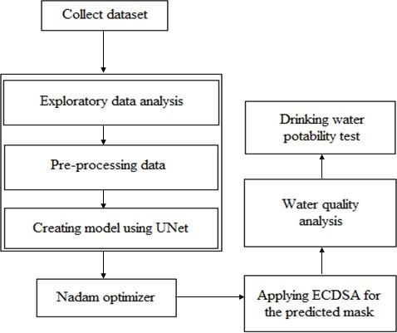
Figure 1. Proposed model workflow diagram
  - Data Set
There are a total set of 2841 satellite images from Sentinel-2 and their corresponding masks data for training the model derived from Sentinel-2 satellite images was obtained from Kaggle. Water bodies and masks are its two classes of the sample dataset and the only parameters in the data set are the images themselves. White denotes the presence of water, while black denotes the presence of other features than water.
PP Each image must be paired with its correct mask using a stable filename or identifier. Duplicate pairs and unreadable files should be identified before splitting the data. Images and masks must undergo identical spatial transformations; masks should be resized with nearest-neighbour interpolation to avoid creating fractional class labels. If the dataset contains multiple tiles from the same scene or overlapping spatial regions, the split should be performed by scene or geographic unit rather than by randomly assigning individual tiles, reducing the risk of spatial leakage. The collected dataset is fed to the model.

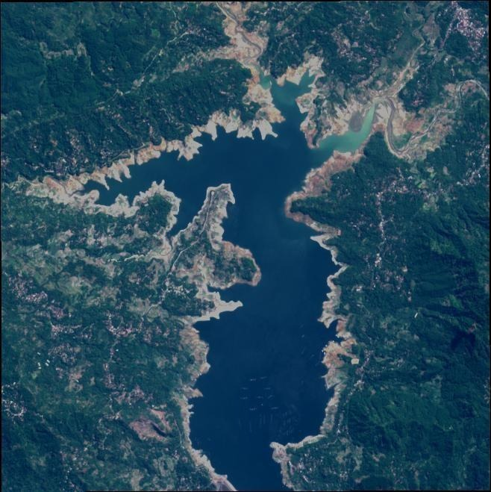
Fig.5. Sample image from Sentinel-2 satellite
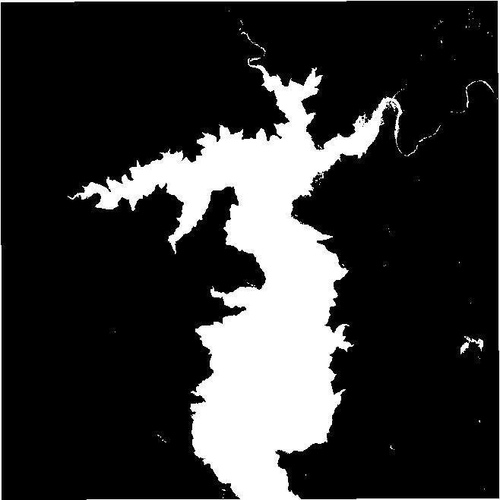
Fig.6. Corresponding mask of this image
  - Study Area
Though not a single study area is taken into consideration as it is not a location based study, an example study location image of the Baralu River from 2018 to 2023 has been considered as motivating factor for observation and analysis.
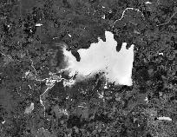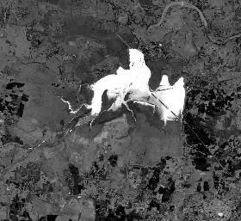
- (b)
Figure 1. Sample study area – Baralu River in 2018(a) and in 2023(b)
  - Exploratory Data Analysis
Through exploratory data analysis (EDA) one can gain knowledge or insight about the distribution and other characteristic of data. Understanding the input data in hand helps in deciding the preprocessing strategies. The exploratory analysis in the proposed work established the need for performing prepocessing which consists of the following steps: Comparing images and masks, Check for Rotation, Check for padding. Firstly, each image must be paired with its correct mask using a stable filename or identifier. Duplicate pairs and unreadable files should be identified before splitting the data. Images and masks must undergo identical spatial transformations; masks should be resized with nearest-neighbour interpolation to avoid creating fractional class labels. It look for padding because the network ought to accept only images that are the same size and that can be divided by the number of down samplings. As a result, masks are divided and images are divided according to their size. If the dataset contains multiple tiles from the same scene or overlapping spatial regions, the split should be performed by scene or geographic unit rather than by randomly assigning individual tiles, reducing the risk of spatial leakage.
  - Preprocessing Data
The initial step before any training model is data preprocessing. The noise, undesirable data, are eliminated in this step to maintain the dataset consistent. The preprocessing of image data achieved with the following steps; Resizing images, Scale values, Pad images. Images with a smaller file size load more quickly than images with bigger file size. To achieve better outcomes, every image in the training and evaluating phases must be of same size. So each image in the collection has been scaled to the same size.
Accordingly, Input images are resized to a common spatial dimension compatible with the network architecture and normalized to a consistent numerical range. The implementation of usmask_split_threshold function describes scaling image values to [0, 1]. The same transformation must be applied to every training, validation, and test image. Binary masks are converted to 0/1 labels using a documented threshold. Padding should be used only where required by the network dimensions, and padded regions should be excluded from evaluation if they do not correspond to valid image pixels.
To improve robustness, data augmentation may include horizontal and vertical flips, 90-degree rotations, and modest brightness or contrast variation where these transformations are appropriate for the imagery. Geometric transformations must be applied jointly to images and masks, while radiometric transformations should be applied to images only. Augmentation must be performed on the training set after the dataset has been split; validation and test data must remain untouched to provide an unbiased assessment.

3.3 U-Net Segmentation Architecture
U-Net follows an encoder–decoder design. In the encoder, successive convolutional blocks learn increasingly abstract features while pooling reduces spatial dimensions. The decoder upsamples these representations and combines them with encoder feature maps through skip connections. These connections help retain fine spatial information that can otherwise be lost during downsampling [3]. For binary segmentation, a final 1 × 1 convolution with sigmoid activation produces a water probability for each pixel. The source implementation describes convolutional blocks with 64 filters at the initial stage, batch normalization, max-pooling, and a sigmoid output. The exact number of levels, convolution-kernel sizes, filter progression, dropout settings, input dimensions, and parameter count should be reported from the implementation before submission. These architectural details cannot be inferred reliably from the current manuscript alone.
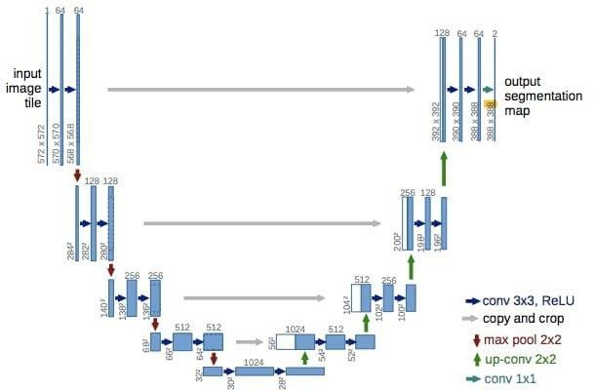
Fig. 1. U-Net encoder–decoder architecture reproduced from the source manuscript. The exact configuration should be checked against the implementation used for training.

Four decoder and encoder blocks which are combined by a bridge to build the U-shaped network architecture. To produce high accurate segmentation with less number of training images, the architecture of network is extended and converted from a fully convolutional network's original design.
The UNet algorithm works effectively for classification of binary data and well for image segmentation. Multiple channels of feature maps are utilised in the implementation, along with a few other processes. The three components that make up UNet are the convolution, encoder, and decoder blocks. The kernel is initialised first, and then the resultant layer's sigmoid activation function is used. Each and every requirement, including concealed activation, startup, and output activation values are defined. The padding is unchanged while basic operations are performed by convolutional blocks which includes 64 filters.

3.4 Optimization and Loss Function
The model is reported to use the NAdam optimizer, which combines adaptive moment estimation with Nesterov-style momentum [7]. Training minimizes a segmentation loss between the predicted probability map and the reference mask. The source manuscript does not identify the exact loss function; the authors should verify whether binary cross-entropy, Dice loss, or a combination was used and report the learning rate, batch size, number of epochs, stopping criterion, and model-selection rule. These settings should be stated rather than reconstructed retrospectively.
For inference, the model produces a probability map P(x,y). A binary mask can be obtained using a threshold τ: M(x,y)=1 when P(x,y)≥τ, and M(x,y)=0 otherwise. The threshold should be selected using validation data and then fixed before final test evaluation. Selecting a threshold on the test set would bias the reported performance.

3.5 Experimental Design and Evaluation
The dataset should be divided into independent training, validation, and test subsets. A split such as 70:15:15 may be used if it is compatible with the dataset size and spatial structure, but the actual split used must be reported accurately. Where spatially adjacent tiles or repeated observations occur, group-wise splitting by scene or location is preferable. A random seed should be fixed and documented.
Visual inspection is useful for identifying boundary errors but is not sufficient to quantify segmentation quality. The following metrics are recommended for the held-out test set: precision, recall, F1-score (Dice coefficient), intersection over union (IoU), and pixel accuracy. IoU and F1 are especially important where water occupies a small proportion of the image, because overall pixel accuracy can be inflated by correctly classifying the larger non-water background. The model should also be compared with at least one simple baseline, such as NDWI thresholding, and preferably a standard CNN segmentation baseline. No numerical scores are inserted here because the source manuscript does not supply verifiable values for these metrics.

The encoder's design architecture takes input starting at the top layer and working its way down. Convolution block is used, and the batch normalisation layers are then applied. Down sampling and maximum pooling are carried out once input has been transferred to these layers. The following outputs are provided after these functions have been applied. Simpler in design, the decoder block measures the quantity of filters in a particular cycle using input from upper levels. The filter and supply count sizes are increased. The output is subjected to convolution block operation, which results in the return of its final value.
Nadam Optimizer: After building the model, this Optimizer is invoked. Nadam is imported from keras module. The fundamental method of optimisation is gradient descent; however, Adam and Nadam were invented to fix its shortcomings. In the Nadam optimizer, NAG momentum is utilised.
Applying ECDSA: The projected mask is enhanced with an Elliptic Curve Digital Signature (ECDSA) to further strengthen the planned deep learning model's fidelity. It makes use of elliptic curve cryptography keys. By translating signing key to the bytes, output digital signature is achieved. NIST192p obtains the signature key, which has a length up to 24 bytes. Verification key can be extracted from this sign key in order to validate digital signature that was generated at another end. The final product appears to be the initial picture with the required mask and mask attached and an ECDSA digital signature.
Water quality analysis: Knowing the quality of water is important for healthy life, based on the quality further development on water bodies can be done. Based on the following factors water quality analysis is done. Depending on the range of its factors, quality of water is known. For the best quality;
Table 1. Factors affecting water quality and their ranges for good water quality
S.NO. | Factor | Range
1 | Temperature | [ 20ºC to 30ºC ]
2 | Dissolved oxygen | [4mg/L to 8mg/L]
3 | Acidity-pH | [ 6 to 8 ]
4 | Specific conductance | [ 150℧ /cm to 500℧ /cm ]
5 | Biochemical Oxygen  Demand (BOD) | [ ≤5mg/L ]
6 | Nitride and Nitrate | [ ≤5.5mg/L ]
7 | Fecal coliform | [ ≤200MPN/100mL ]

Drinking water portability test: Water portability test for drinking should be done as drinkable water plays key role in our lives. Using Machine learning algorithms and by considering the following factors this test is done.
Table.2. Factors effecting drinking water portability and their ranges for safe use
S.No. | Factor | Range
1 | pH | [ 6.5 to 8.5 ]
2 | Hardness | -
3 | Solids | [500mg/L to 1000mg/L ]
4 | Chloramines | [ 4ppm ]
5 | Sulfate | [ 3mg/L to 30mg/L ]
6 | Conductivity | [ <400 μS/cm ]
7 | Organic Carbon | [ <2mg/L ]
8 | Trihalomethanes | [ ≤80ppm ]
9 | Turbidity | [ 5NTU ]

  - Machine Learning Algorithms
Logistic regression: It is a Machine Learning algorithm which is most regularly used in the category of Supervised Learning. To forecast dependent variable categorically using particular set of variables which are independent, it’s used. It gives a categorically dependent variables as a result. The result should be of a discrete value. Instead of giving accurate values of 1 and 0, it gives the values which are probabilistic which falls between 1 and 0. It may be either No or Yes, 1 or 0, false or true, etc. It is used for solving the classification problems.
Decision tree: It is a tree like structure classifier, in which every leaf node symbolises the outcome’s classification and the features of dataset represents inside nodes.
Random forest classifier: It is grounded on concept called ensemble learning, that is one technique used for joining many classifiers so that handling challenged problems and better model performance can be done.
K nearest neighbor: Using the method of K-NN, new data can be fastly and precisely sorted into right category. Although this technique is most regularly employed for the problems of classification, and it can be also used for regression.

Support vector machine: This method seeks to find the most effective decision line or boundary which can seperate the space with n dimensions into classes in order to quickly analyse newly collected information in the future. The name for this ideal decision boundary is a hyper plane.
Adaboost classifier: The idea behind Adaboost is to train the sample data and set the weights of the classifier in each iteration in order to guarantee precise predictions of the observations which are uncommon.
Xgboost classifier: Extreme Gradient Boosting, is the most famous and mostly used ML algorithms because it is able to handle the larger datasets. Additionally, it is very adaptable and enables performance optimization through the fine-tuning of numerous model parameters.
- Results and Discussions

4.1 Qualitative segmentation outputs
The supplied manuscript contains visual examples of input imagery, reference masks, and U-Net-generated outputs (Figs. 2–3). They are retained here as qualitative illustrations from the source material. Because the original figure files do not establish which images belong to a held-out test set, the examples cannot be treated as independent validation evidence. The manuscript therefore makes no numerical accuracy or superiority claim.

Fig. 3. Qualitative examples of input imagery and segmentation outputs reproduced from the source manuscript. These visual examples are illustrative only and do not substitute for held-out test metrics.
The figures retained in this version are labelled according to the content that can be identified from the supplied manuscript. Before submission, the authors should verify that displayed inputs, reference masks, and predictions refer to the same examples, and replace low-resolution composites with publication-quality panels where possible. Successes and failure cases should both be shown.

4.2 Interpretation and limitations
The workflow is a practical starting point for automated water-mask generation. Its main potential benefit is the ability to learn contextual and boundary information beyond a fixed spectral threshold. Nevertheless, the current evidence is preliminary because the source manuscript does not report a defined study area, acquisition dates, a reproducible data split, numerical segmentation scores, uncertainty estimates, or a comparison against established baselines. Without these elements, the relative performance of U-Net cannot be determined.
Further, Sentinel-2 imagery can contain cloud, cloud shadow, atmospheric effects, mixed shoreline pixels, and seasonal changes in water appearance. Small ponds and narrow channels may be missed when their width approaches the pixel size. A model trained on a single dataset may also learn dataset-specific characteristics and fail in a different landscape. Future evaluation should therefore stratify results by water-body size, land-cover context, season, and geographic region where reference labels permit.

4.3 Scope of water quality and security claims
The source manuscript also discusses ECDSA digital signatures, water-quality factors, drinking-water potability classification, and detection of suspicious movement. These are separate tasks and are not demonstrated by the water-segmentation results presented here. ECDSA can authenticate a digital file or verify its integrity, but it does not improve the semantic accuracy of a predicted mask. Similarly, a water-body boundary extracted from satellite imagery cannot establish potability without a separately validated water-quality model and appropriate measurements. To maintain a coherent and defensible conference paper, these topics are excluded from the core method and conclusions. They may be developed in separate studies with their own data, methods, and evaluation.
The following extensions were included in the original manuscript. They are retained here as connected components of a broader water-monitoring workflow, while their evidential status is distinguished from the segmentation experiment.

4.4 From water-mask extraction to river-occupancy monitoring
The original study illustrates the Baralu River in 2018 and 2023 to motivate periodic observation of river occupancy. This comparison provides an application context for the segmentation workflow: water masks generated from comparable satellite scenes can be used to estimate surface-water extent and examine spatial change over time. However, the two dates should be compared only after confirming image acquisition dates, seasonal comparability, spatial resolution, cloud conditions, and consistent delineation. The current manuscript does not provide a quantitative change estimate, so the examples are treated as an illustration of the intended application rather than proof of measured river loss or gain.

4.5 Digital-signature-based integrity of predicted masks
The original manuscript applies the Elliptic Curve Digital Signature Algorithm (ECDSA) to predicted masks. This component can be retained as a data-integrity step after segmentation: a digital signature can help a recipient verify that an exported mask or associated record has not been altered and that it was signed using the expected private key. It does not improve the U-Net prediction itself, verify whether the mapped water is correct on the ground, or guarantee the accuracy of the segmentation. A reproducible implementation should report the cryptographic library, curve and key-generation procedure, signed file format, verification procedure, and the result of a tampering test. The manuscript’s security demonstration should therefore be understood as a separate integrity check linked to the mapping output, not as a segmentation-performance metric.

4.6 Water-quality and drinking-water suitability as downstream applications
The original manuscript also discusses water-quality factors, drinking-water potability, and tabulated ranges for parameters such as temperature, dissolved oxygen, and pH. These topics are relevant to water-resource management, but they require measurements or a separately documented water-quality dataset. A satellite-derived water mask identifies the spatial extent of visible surface water; it cannot, by itself, establish chemical or microbiological quality or determine whether water is safe to drink. In an integrated system, the extracted water-body locations could be linked to field or laboratory measurements and then used to map the availability of water-quality observations. Any classification of water quality or potability must state its data source, target labels, parameter definitions, missing-value handling, train/test design, and validation results. The parameter ranges reproduced in the original work should be checked against the relevant standards and the dataset documentation before being presented as thresholds for safe use.

4.7 Role of conventional machine-learning classifiers
The original manuscript describes logistic regression, decision trees, random forests, k-nearest neighbours (KNN), support vector machines (SVM), AdaBoost, and XGBoost, and reports SVM as performing well for a drinking-water classification task. These methods are not interchangeable with U-Net: the classifiers normally operate on tabular features or engineered descriptors, whereas U-Net predicts a pixel-level mask. Their place in the proposed workflow is therefore downstream, where verified water-quality measurements can be classified into explicitly defined categories. The reported SVM result should be retained only as a result of that separate experiment if the underlying dataset, evaluation protocol, and accuracy scores can be supplied. Otherwise, it should be described as an intended analytical extension rather than a verified finding of the present water-body extraction study.

4.8 Extension to additional images and video
The source manuscript also shows predictions on additional images and video frames. These examples suggest a possible route towards repeated or near-real-time visual monitoring, but they represent a different input setting from the paired satellite-image dataset used to train the model. Video frames may differ in viewpoint, scale, lighting, sensor characteristics, and background from Sentinel-2 imagery. Consequently, successful-looking outputs on such frames do not establish generalisation unless the input type, preprocessing, reference masks, and evaluation procedure are documented. This application is retained as future work: a dedicated dataset and independent validation would be needed before describing the model as a video-based water detector.

4.9 Integrated interpretation
Taken together, the original components can be organized as a modular water-monitoring pipeline: (i) U-Net generates a candidate surface-water mask from satellite imagery; (ii) repeated masks support temporal assessment of river or water-body extent; (iii) ECDSA can protect the integrity of exported results; and (iv) water-quality measurements, where available, can be analysed by conventional machine-learning classifiers. Video-based detection remains a separate extension requiring its own data and testing. Keeping these modules distinct makes the overall concept coherent without implying that the segmentation model has already validated every downstream function.
The below image represents the sample image and its resulting mask.
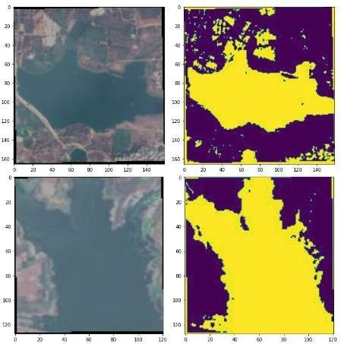
Fig.7. Sample image with corresponding mask from data set
The below figure is the result of exploratory analysis of the data. To observe the dynamics of the data, a histogram is created.
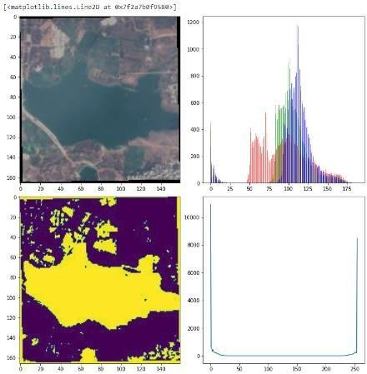
Fig.8. Statistics of Exploratory data analysis
Here, following two figures are the outputs of UNet model which detects the predicted area taking original images and original masks as inputs.

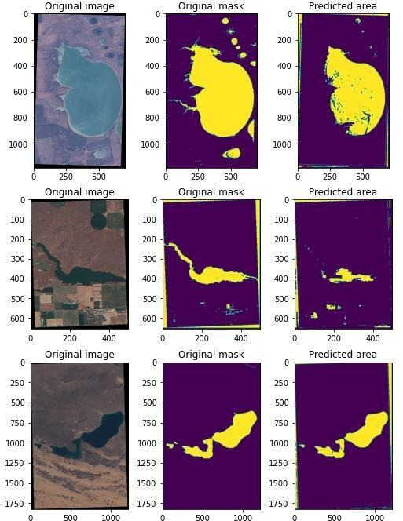
Fig.9. Predicted output of UNet model
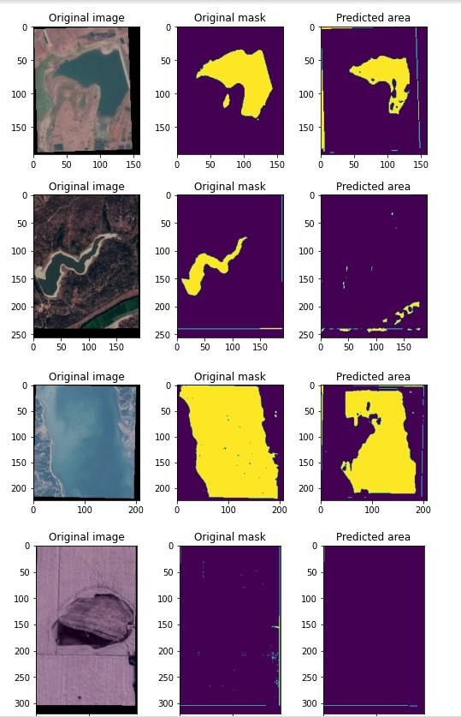
Fig.10. Predicted output of UNet model

ECDSA Outputs:
As security feature is important, using ECDSA digital signatures had been generated.
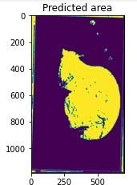 | k\x81\x10\xc6\x8c\xc5"\xb9\x8e\xe1<_\x b8\x08Q\x8e\xbe;\x872\x83\xe3\x00x\xff  \xb7\xed\x906\xf47\xec\xda\x01\x03\xfd  \xb7\xd7Vg{\x83\xfc\xcfE\x1f?\x1f
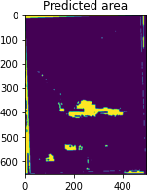 | '\xaf\x84\xe7\x89\x86c\x89\xe4\xefM\x1 b\x84\xd6\xbc\x18\xd6\x88\xe4\xe7\xf9\ x0b\xdb\x90Z\x9f\x0fY!3\x1d\x93\xed,[\ x11b\xe8\x1c\xee\xf4{\x11\x9c\x80\xdf\ x99\x07
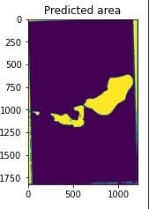 | \x8a\x91dg\xb1\xf7]\xb0\xe7\xbfm\x00\x0 e\x1e\x83<\xf5a\x15X\xabs\xf3.Sq\x1a=_\ xc8\x14\xda\xb34\x02\x07\xe1\x8b\xb1e\x 84\xe1k\xf1\xfc\x9a\x81

Fig.11. Predicted Image and Digital signature 1 – 3
To check working of UNet on other data sets, outputs have been generated.
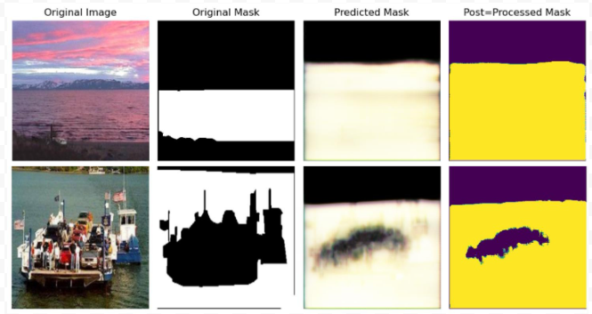
Fig.12. Model application on regular images
Apart from images, now video is given as an input to the model
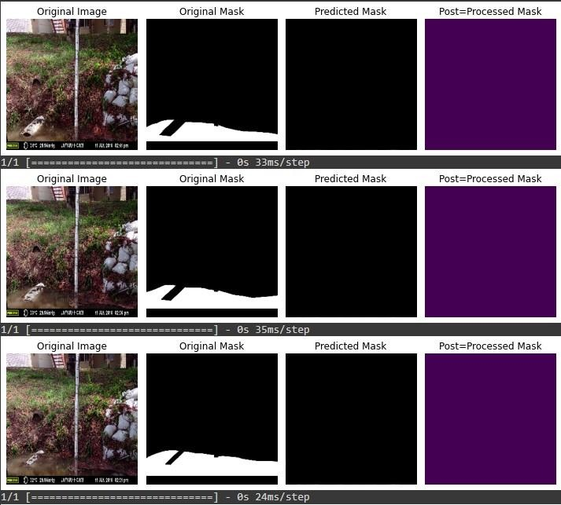
Fig.13. Predicted mask for video input 1
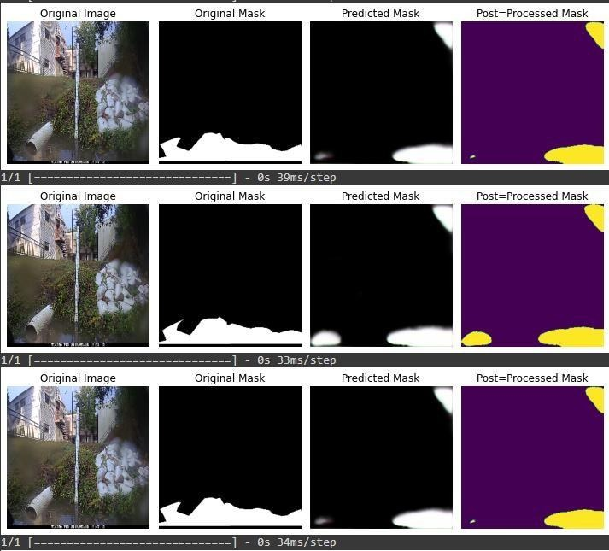
Fig.14. Predicted mask for video input 2
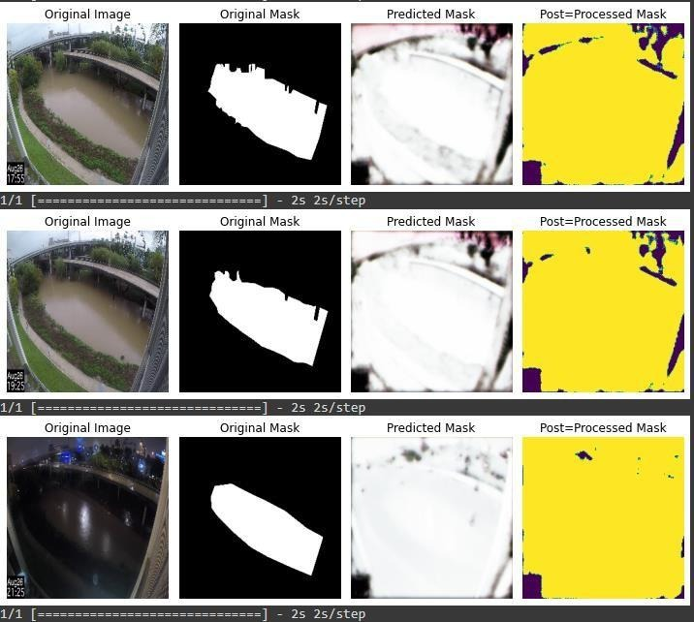
Fig.17. Predicted mask for video input 3
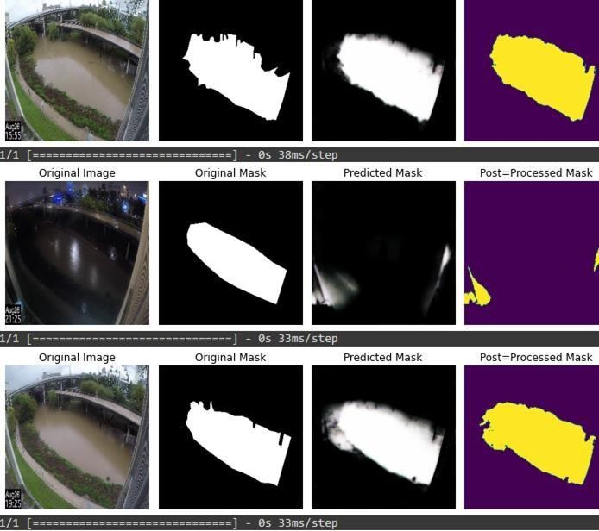
Fig.18. Predicted mask for video input 4
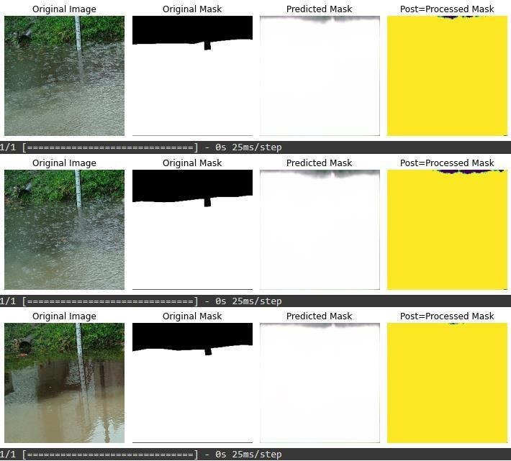
Fig.19. Predicted mask for video input 5

Considering the data set of Indian water bodies, and factors effecting their quality, below is the bar graph which represents the state with best water quality.
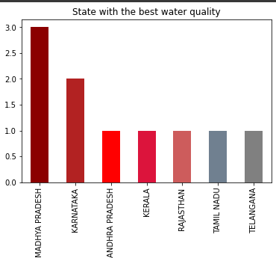

Fig.15. State with the best water quality
Considering the data set of factors effecting water potability, using different Machine Learning algorithms, SVM with high accuracy gave best results.

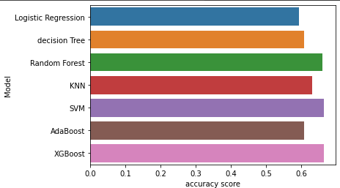
Fig.21. Accuracy score for different ML algorithms

- Conclusion And Future Plan

Detection of water bodies is done successfully and accurately using UNet architecture. Applying ECDSA to the predicted mask added a new security feature to the model. For the sustainable development of water bodies, which are identified using the model, and with their regular monitoring, to protect them with new developments, water quality analysis along with the drinking water potability test is done. Considering country’s safety from intruders, because of its semantic segmentation, UNet model can accurately detect the suspicious movements. Taking the factors effecting water quality and drinking water potability in to account, we can protect and use water bodies for good and healthy life.

This paper documents a U-Net-based workflow for extracting surface-water masks from paired satellite images and binary reference masks. The source material reports 2,841 image–mask pairs and provides qualitative examples of model outputs (Figs. 2–3). A complete evaluation requires a documented dataset source, a leakage-aware held-out test set, the exact training configuration, numerical precision, recall, F1/Dice and IoU scores, and a comparison with an NDWI baseline.
The next stage should establish dataset provenance and geographic coverage, document the complete network and training configuration, use a leakage-aware independent test set, and report precision, recall, F1-score, IoU, and pixel accuracy. Comparison with NDWI thresholding and at least one alternative segmentation model would provide a stronger basis for judging the method. Cross-region and cross-season testing would be needed before operational use. Once segmentation performance is established, the generated masks could support water-extent change analysis and water-resource inventory; water-quality assessment would require a distinct model and suitable reference observations.

References
- New deep learning method for efficient extraction of small water from remote sensing images- doi:10.1371/journal.pone.0272317; Yuanjiang
- ECDSA-Based Water Bodies Prediction from Satellite Images with UNet- https://www.mdpi.com/2073-4441/14/14/2234; Anusha Ch, Rupa
- Patrik Helber,EuroSAT: A Novel Dataset and Deep Learning Benchmark for Land UseandLandCoverhttps://www.researchgate.net/publication/319463676_EuroSAT
- A_Novel_Dataset_and_Deep_Learning_Benchmark_for_Land_Use_and_Land_ Cover_Classification
- Towards synoptic Water Monitoring Systems: A Review of AI Methods for Automating Water Bpdy Detection and Water Quality Monitoring Using Remote Sensing- doi:10.3390/s22062416
- Juliandy, C.; Pribadi, O. Securing Medical Records of COVID-19 Patients Using Elliptic Curve Digital Signature Algorithm (ECDSA) in Blockchain. CommIT (Commun. Inf. Technol.) J. 2022, 16, 87–96
- Rajyalakshmi, C.; Rao, K.R.M.; Rao, R.R. Compressed High Resolution Satellite Image Processing to Detect Water Bodies with Combined Bilateral Filtering and Threshold Techniques. Trait. Signal 2022, 39, 669–67
- Drusch, M., Del Bello, U., Carlier, S., Colin, O., Fernandez, V., Gascon, F., et al.: Sentinel-2: ESA's Optical High-Resolution Mission for GMES Operational Services. Remote Sensing of Environment 120, 25–36 (2012). https://doi.org/10.1016/j.rse.2011.11.026
- McFeeters, S.K.: The use of the Normalized Difference Water Index (NDWI) in the delineation of open water features. International Journal of Remote Sensing 17(7), 1425–1432 (1996). https://doi.org/10.1080/01431169608948714
- Ronneberger, O., Fischer, P., Brox, T.: U-Net: Convolutional Networks for Biomedical Image Segmentation. In: Navab, N., Hornegger, J., Wells, W., Frangi, A. (eds.) Medical Image Computing and Computer-Assisted Intervention – MICCAI 2015. Lecture Notes in Computer Science, vol. 9351, pp. 234–241. Springer, Cham (2015). https://doi.org/10.1007/978-3-319-24574-4_28
- Luo, Y., Feng, A., Li, H., Li, D., Wu, X., Liao, J., et al.: New deep learning method for efficient extraction of small water from remote sensing images. PLOS ONE 17(8), e0272317 (2022). https://doi.org/10.1371/journal.pone.0272317
- “Deep Learning for Automatic Extraction of Water Bodies Using Satellite Imagery.” Journal of the Indian Society of Remote Sensing 51, 1511–1521 (2023). https://doi.org/10.1007/s12524-023-01705-0
- Yang, L., Driscol, J., Sarigai, S., Wu, Q., Lippitt, C.D., Morgan, M.: Towards Synoptic Water Monitoring Systems: A Review of AI Methods for Automating Water Body Detection and Water Quality Monitoring Using Remote Sensing. Sensors 22(6), 2416 (2022). https://doi.org/10.3390/s22062416
- Dozat, T.: Incorporating Nesterov Momentum into Adam. In: International Conference on Learning Representations (ICLR) Workshop (2016).

